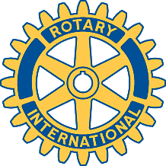

Rotary Club of Carleton Place and Mississippi Mills

Meeting of November 20th, 2017

The club held a dinner at the Grand Hotel to celebrate the 15-year anniversary of the granting of its charter.

The guest speaker was Allan Mallory (allanmallory.com), who spoke about his experience in climbing Mount Everest.

Club website : http://carletonplacerotary.ca

