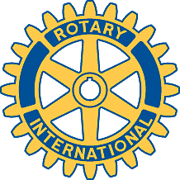

Rotary Club of Carleton Place and Mississippi Mills

Meeting of July 31st, 2017

Attendees: Al, Heather, Rick, Deb, Kathy, David, Eric, Bernie, Mike, Marion
Special Guest: Wayne Desormeaux from the Kempville Club

"Oh Canada, Prayer and Happy Dollars"

Chase the Ace - $177.50 - Wayne pulled ticket #9295 - Mike - and Mike pulled the King of Hearts.

Mike to give Al the "books" for Al to audit.

Trail Maintenance - David to get ahold of Kevin Morrow.

A motion to get a new folding table was put forth. Eric motioned, Mike 2nded, and all passed.

Again, a reminder for the District Conference - Sep 29 and 30th, Akwesasne Casino and Resort.

Induction Ceremony - Welcome to Heather and Rick. Deb Shaw sponsored and pinned them both.

The approval for the free Canoe Club Rental for the Casino Night passed finally came through. (for 2017)

Thank you to Mike for replacing our missing Bell.

Next meeting is Aug 14 as the Moose is closed on the 7th.

A side note - Eric and Sue are holding a Bar b q to raise funds to support their Honduras Project. There will be beef, turkey and other good stuff. It is their 6th annual to be held at 152 Metcalfe St in Almonte. The date is Sat Aug 26 starting at 2:30 pm til whenever. A silent auction will be held also.

Meeting adjourned.

Club website : http://carletonplacerotary.ca

