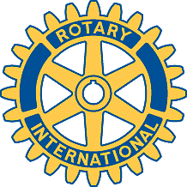

Rotary Club of Carleton Place and Mississippi Mills

Meeting of February 13th, 2017

Louis Gaudreau, President of the Perth club, with Frank Larabie were special guests.
Attendees: Ernie, Brenda, Mike, Teresa, Sarah, Deb, David, Kathy

Oh Canada, Prayer, Happy Dollars.

Chase the Ace - $760.00. Ticket ending with 684, was David's and he pulled the 5 of clubs from the deck.

Casino Night - most things organized. Would like to have a spot light to get the event noticed more, and give a Las Vegas atmosphere. Absolutely need Silent Auction items.

Membership Committee - Sarah and Faye working closely together.

Teresa and Bernie to interview 3 students for Adventures in Citizenship.

Paul Harris award to be given to a member of our club, chosen by club. Ernie motioned, David 2nded, all in favour. To be discussed at board meeting.

Louis Gaudreau did his presentation of his club.

Meeting adjourned.

Club website : http://carletonplacerotary.ca

