Rotary Club of Carleton Place and Mississippi Mills
Meeting of January 26, 2015

There were only 8 members in attendance but that number was complemented by six guests plus our speaker Jennifer Debruin. Prior to Jennifer’s talk Acting President Bob conducted a brief business meeting during which the following items were discussed:
- Marion and Brenda reported that all action necessary for our request of a Certificate of Continuance had been completed (a necessary step in the process of obtaining charitable status).
- Gordon reported on a donation from Wendy LeBlanc.
- Faye reported that 13 boxes of food had been collected for the Food Bank at the Carleton Place Independent Grocery on January 24 plus $120 worth of cash donations. A highly successful result thanks to Faye and her team.
- A meeting of the Membership Committee is planned for February 4.

Bob provided a brief overview of Rotary both locally and internationally for the Club’s guests and then introduced Jennifer who spoke about the “Lost Villages of the St. Lawrence”, the nine villages flooded as a result of the building of the St. Lawrence Seaway in the 1950’s. The locations of the villages are shown below.

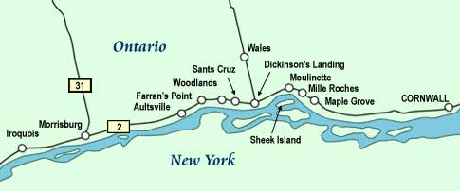
Jennifer’s interest in the subject was sparked by her grandmother Mary’s stories of being one of the 6,500 people displaced by the flooding. Many buildings, especially the old stone structures could not be moved and therefore were levelled. Jennifer urged members to visit the Lost Villages Museum just off Highway 2 at Long Sault. Her talk was followed by an interesting and informative question period.

