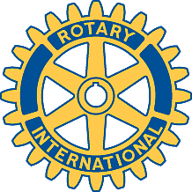

Rotary Club of Carleton Place and Mississippi Mills

Meeting of July 29th, 2013

Sarah Chisholm (formerly Bennett) gave her presentation on the Almonte Train Disaster.

